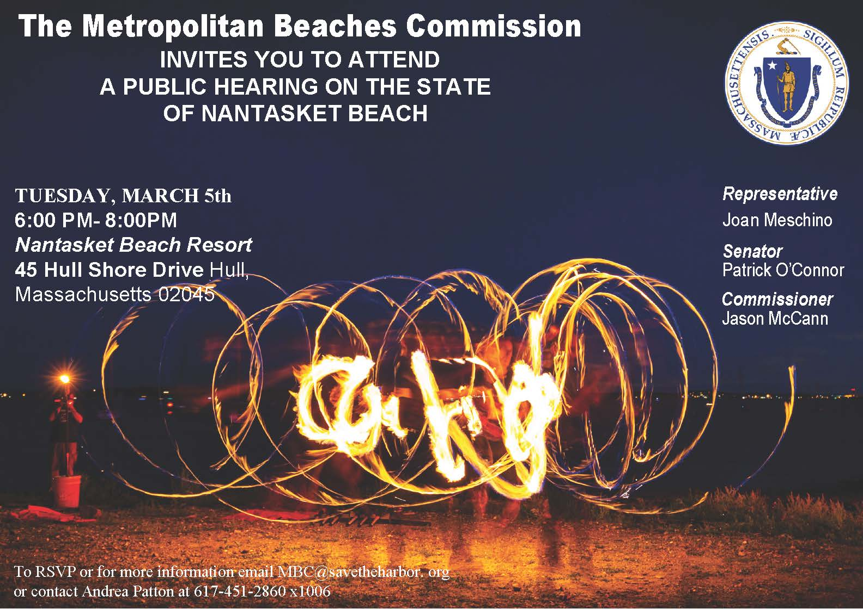

Transportation
- Broadly there is concern about traffic and parking management.
- Especially during the summer months congestion on Nantasket Ave can be severe.
- Parking options are varied along the beach which raises a variety of frustrations and concerns including: lack of availability of parking, appreciation of the free parking that exists and concurrent frustration that after the free parking fills up, it can cost $20 or more to park for the day in the private spaces.
- Recommendations for improving the parking situation include continuing to charge at metered spots after 4pm, encourage more parking on the bayside, and operating a shuttle to lots that are further away.
- There is a clear desire for improvements in public transportation options including connecting to the commuter rail and expanding water shuttle and trolley operations.
Accessibility
- The accessibility ramps and mats are often covered in rocks and impassable.
- Accessible parking spaces are scarce.
- Greater need for the large wheelchairs designed for sand, as well as increased marketing of their availability.
Safety
- Generally the beach feels safe and lifeguards and state police were praised.
- Some improvement could be made to being able to communicate with police officers.
- Concerns about safety of pedestrians on boardwalk when cyclists speed by.
Capital Projects
- Concerns were raised about the sand being used for the beach nourishment project potentially being contaminated.
- Sidewalks and parking lots need paved.
- More shade and green space desired along the beach.
- Want to make sure that the master plan is executed.
Events and Programs
- Programs and events are some of the best things about the beach. Additional events such as movie nights, art activities, and yoga on the beach were suggested.
- More activities that can take place at both low and high tide, as well as all year round.
Communication
- Need better communication about events and issues such as water quality tests.
- Communication about the various long-term planning processes could be improved.
- Want to see more public education on climate change/sea level rise.
Amenities and Neighborhood Development
- Everyone recognized that Nantasket Beach is an economic driver for the region, and were excited about the many new developments that are coming online.
- There is a desire to see expanded all-season opportunities, as well as more outdoor venues such as beer gardens or patios at the restaurants.
- The DCR-managed amenities such as the Mary Jeanette Murray bathhouse were complimented for being clean and well maintained.
- Some improvement could be made to the amenities including adding indoor showers, more landscaping at the Murray bathhouse.
- Open question about what work is being done at the Bernie King Pavilion.

