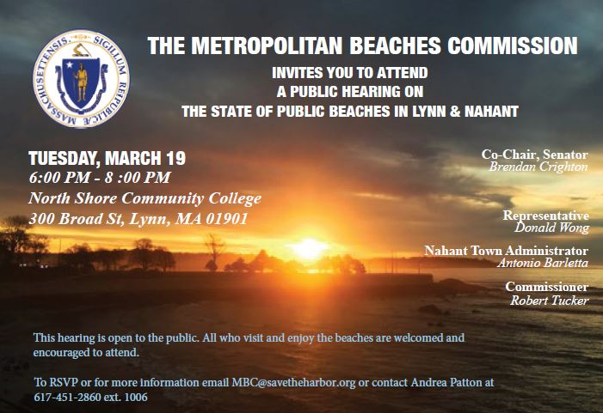

Maintenance, Amenities, and Natural Environment
- Many participants commented on the landscaping and natural ambiance at area beaches, complimenting the flowers, dunes, and design of facilities
- Comments regarding cleanliness and upkeep were overwhelmingly positive and complimentary of DCR’s efforts to empty trash barrels, clear sidewalks of sand and snow, plow Lynn Shore Drive, cut grass, and clean the bathhouses.
- Residents have concerns about the dunes particularly at Nahant and Long Beach, that they are not being maintained and that ropes and fences to keep people and dogs off of the dunes are ineffective.
- There is a strong desire to see clearly marked and regularly stationed recycling bins on and near the beach, as well as an effort to consider removal of plastics that might wash onto the beach from the ocean.

Needs and Opportunities
- Beach lovers enjoy the existing programs including the Red Rock Summer Concert Series, Kids Fest, beach wrestling tournament, and Beach Sisters Program.
  - Even so, there is a desire to see more events and programs at all beaches and parks in Lynn and Nahant, and more varied offerings including in the concert series, a big festival with vendors, all season events, biology, conservation, and citizen science programs for youth and adults.
- Participants expressed a desire to see concessions and vendors at and on the beaches.

Capital Investment
- Recently completed capital investments including new benches at Red Rock Park and the playground at Ward Bathhouse are appreciated.
- Recommendations for additional capital investments included:
  - Upgrading the sea wall with more resilient materials and other climate change preparations especially at Kings Beach and for Lynn Shore Drive;
  - Repairing crumbling stairs at Kings Beach and replacing rusted railings instead of repainting them;
  - Re-grading the walk to Red Rock Park from the beach and the parking lot to make it less dangerous;
  - Increasing the number of benches along Nahant Beach and adding showers at the Tides End;
  - Adding more water fountains;
  - Adding shade shelters and bathroom facilities at Red Rock Park;
  - Adding toilets along Kings Beach and having them available year round; and
  - Repainting center yellow traffic line, parking lines, and crosswalks on Lynn Shore Drive particularly at the Nahant Rotary.

Water Quality and Algae
- While the water quality at Nahant Beach was praised, and efforts by DCR to remove the algae at Kings Beach were appreciated, significant frustrations regarding the on-going pilayella algae and water quality challenges at Kings Beach remain.
  - Regarding the algae, several participants raised concerns regarding the precarious nature of funding for removal in the budget every year and expressed a desire for dedicated funding so that removal can begin earlier. Residents also called for more research as to the cause of the algal blooms and a permanent solution for the problem.
  - Regarding water quality at Kings Beach, attendees called the bacteria levels unacceptable and called for a permanent fix, especially to the contamination problems from the Stacey’s Brook outfall. They also called for increased funding from the Commonwealth to support Lynn and Swampscott in a coordinated effort to solve the issue.

Public Education
- Residents expressed a desire for more public education efforts on a variety of issues.
- The majority of comments on this issue were participants expressing a desire for better signage at Kings Beach regarding water quality testing results, particularly at Stacey’s Brook. One breakout group expressed a desire to see flags on Lynn Shore Drive so that people traveling to the beach see the postings before getting all the way to the sand.
- Several attendees also requested public meetings and events to discuss the algae and water quality concerns and what is being done to address them.
- Folks would like to see information about who to contact with issues at various points around the beach, including maintenance and safety concerns as well as better communication about events happening both on and about the beach.
- Educational signage about local history, environmental awareness, and flora and fauna.

Connections
- Attendees appreciate the redesign of the parking lot at Long Beach, the bike path at Nahant, and the fact that pedestrians do use the crosswalks on Lynn Shore Drive.
- Folks want to see better enforcement of traffic rules both for cars – particularly speed limits and no truck access locations – as well as cyclists and new rentable bike programs.
- The parking lot at Nahant Beach is regularly logjammed in the summer, which creates a back up on the road particularly at the Nahant Rotary. One participant suggested a sign at the rotary indicating if the lot was full would help.
- Often at Kings Beach the available parking fills up early in the summer, and folks stay parked on Lynn Shore Drive all day because there are no time limits, and some attendees would like to see limits put in place.
- Several participants called for more alternative transportation options including a shuttle from the T, a shuttle from Lynn to Nahant Beach, a ferry, better bicycle routes to the beach and more bike racks, and finally an extension of the Blue Line to Lynn.

Heritage State Park
- This park is not a beach, but is a DCR-owned waterfront property.
- Capital improvements to the mosaic panels and the dock at Heritage State Park are needed, as well as improvements to the signs directing folks to and into the park.
- Parking concerns exist, and re-opening North Shore Community College parking lots of Heritage State Park visitors was requested.
- Additional programming was also requested.

