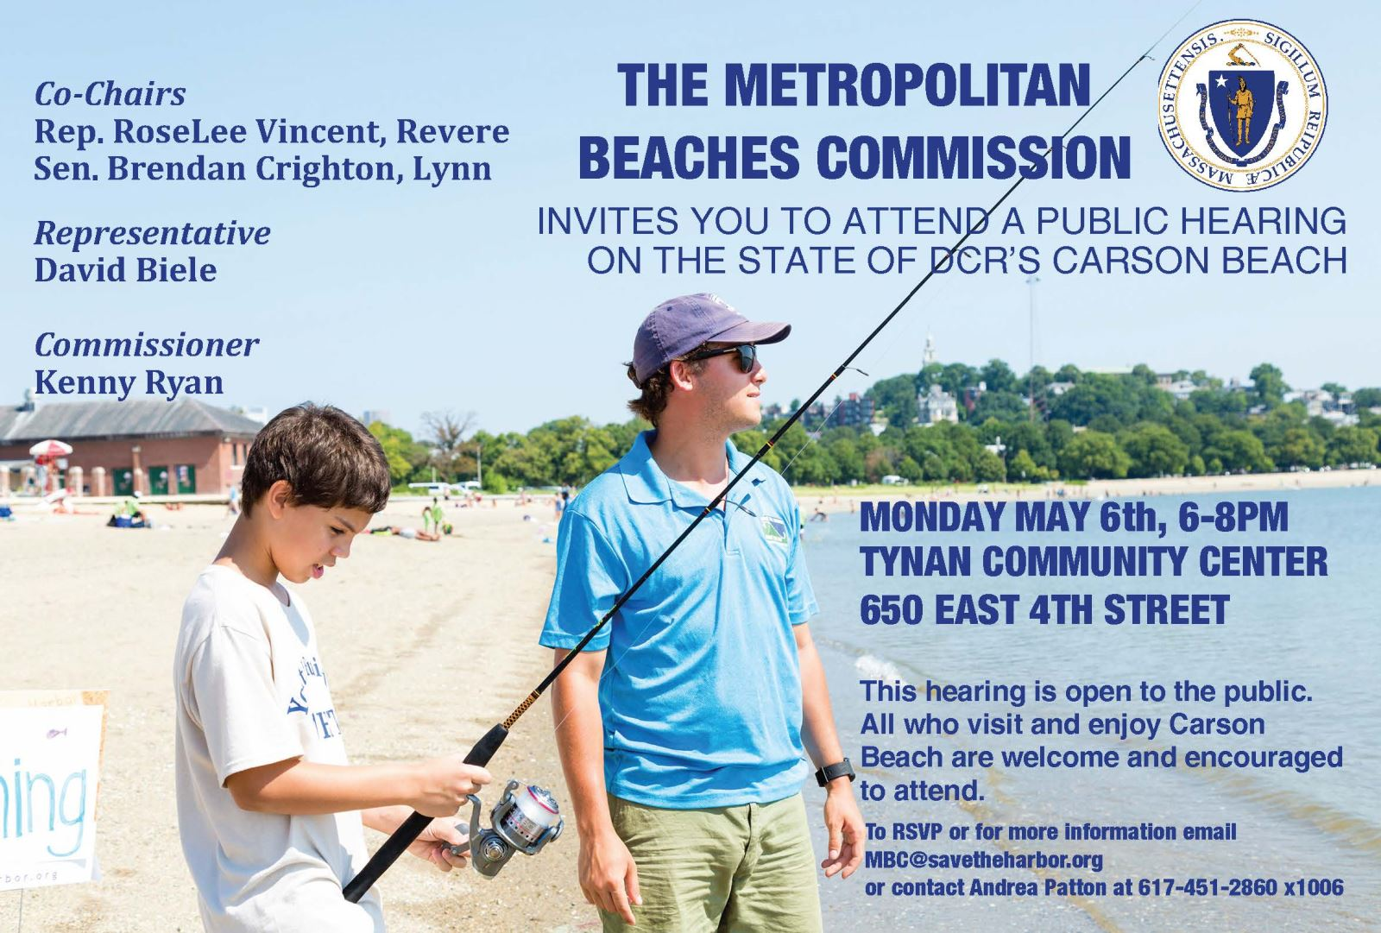

Cleanliness and Maintenance
- All participants appreciated the excellent water quality at both Carson Beach and Pleasure Bay.
- Many attendees also noted that there has been much improvement in the trash/litter problems at the beaches.
- There are still concerns with dog waste, and a need for recycling bins, as well as people dumping large waste (concrete slabs etc.) between Shore Road and the Sullivan’s parking lot.
  - One person also expressed a need for rat control under the boardwalk on Carson Beach.
- There were concerns about the sea walls, both in areas that need fixing and longer term needs for a taller sea wall especially in the face of climate change.

Sand and Landscaping
- Attendees expressed a desire to see better, softer sand at the beach, and highlighted areas that might need more sand including between I and K Street, and the cut through between K and G.
- Beach lovers appreciate the natural landscaping in areas including at the base of G Street and would like to see more landscaping with native plans such as milkweed, golden rod, and asters instead of mowing all plants in the area.
  - One attendee also commented that the plantings near the cut-through to the beach between K and G need more care.

Amenities and Vendors
- People appreciate the restrooms at Pleasure Bay, including that they are open when they need them.
- A desire for more food options was highlighted.
  - One person suggested that the “Pickle Jar” building near the McCormack Bathhouse could be used as a snack bar.
  - Participants were divided on whether they would like to have food trucks in the area.
- Several attendees expressed a desire for more lighting the length of the beaches, particularly in the fall/evening.

Transportation
- Many suggestions were made for changes to parking including more accessible parking at Castle Island, paid parking for shuttles, parking meters at Castle Island for revenue and to discourage all day parking. Participants were also interested in overnight parking options.
- Attendees expressed a desire to see a bus or shuttle along the beach that stops at Castle Island.
- One participant suggested using one of the unused bike lanes for a jogging lane.
- One attendee noted that they did not like the idea of closing Day Blvd to make a permanent bike/ped connection between Moakley Park and Carson Beach.

Events and Activities
- Attendees have concerns about excessive drinking and lack of monitoring disruptive activities on the beach and crowds in the water causing safety concerns.
- One participant would like to see fewer road races.
- Finally one person expressed a desire to keep the Fort at Castle Island for historic tours, not private events.

