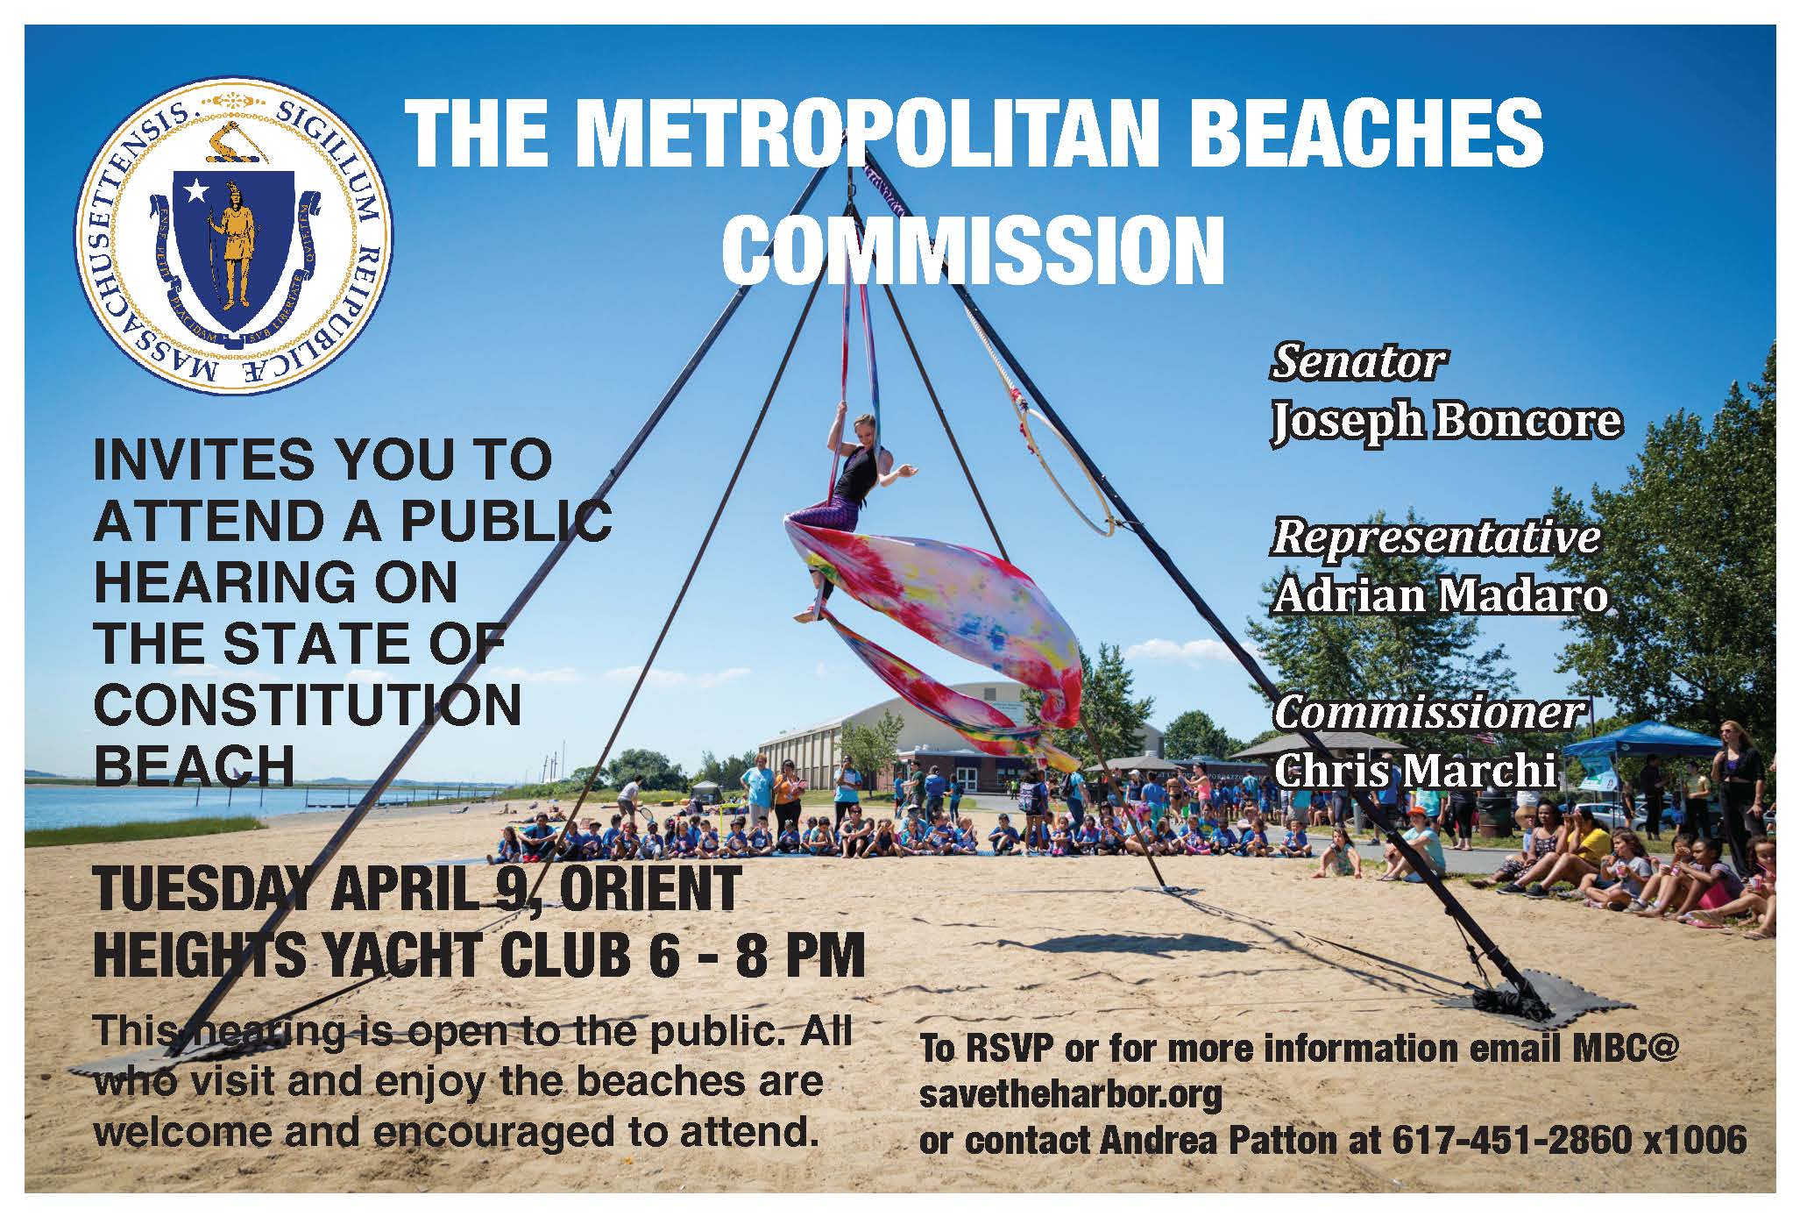

Beach Management and Safety
- Participants noted how much the maintenance and security has improved at Constitution in recent years, including sand grooming, cleaning the bathrooms, and plowing the sidewalks in the winter.
- Many areas with room for improvement were identified including better routine maintenance of the landscaping and built areas including the playground, increasing trash barrels and trash pick up, faster removal of graffiti from the benches, and more plantings.
- Folks also expressed a need for more active and visible staff. While the beach manager was complimented, many noted that he can’t do it all alone and that increased patrols, maintenance staff, and lifeguards are all needed.
- One participant also noted that the roped off swimming area is inadequate at low tide.
- In terms of security, participants noted that there is public drinking and marijuana smoking at the beach and that people experiencing homelessness are living on the beach. Residents requested more patrols and security officers in part to take the burden off of often teenaged lifeguards who should not be put in a position to confront people who are intoxicated.
- Several people also noted safety concerns regarding barbequing and open fires.

Capital Improvements and Accessibility
- People complimented recently completed capital projects including the playground, improved lighting, and the new tennis courts.
- Requests for capital projects included more benches, shade structures, water fountains and water refilling stations, solar charging stations for phones, electric vehicle charging stations, increased tree planting, expanding the men’s room, a boathouse to house the kayaks, more handball courts, a kayak launch pier near the tennis courts, a swimming platform, and dredging at Wood Island Bay Marsh especially for kayak access.
- While the new bathhouses are accessible, beach lovers would still like to see re-paved walkways for better access, ADA accessible swings for adults and youth, and beach wheelchairs.

Bike-Ped Infrastructure, and Vehicle Traffic
- Attendees love the Greenway and would like to see it continued through to Winthrop and Revere, and the existing walking paths.
- Several groups discussed the desire to see the return of the distance markers that used to be on the pathways for runners and walkers.
- There is a high volume of people who come to the beach on foot, and they have created their own paths particularly along Thurston Street which is leading to some erosion.
- Beach lovers would like to a Blue Bikes station at the beach.
- Regarding vehicle traffic, there are concerns regarding speeding through the parking lot. Participants requested more speed limit signs, angled speed bumps, flashing light beacons.
- They also requested repaving parts of the lot and the roads just outside the gates.
- Electric vehicle charging stations were requested.

Events, Amenities, and Public Involvement
- Attendees love the kayaking program that NOAH runs at Constitution and other existing programs like the Harborkeepers Marine Science Festival and camps that the YMCA run at the beach.
- Participants would still like to see more adult friendly programming, including coordinating programming with the new center for seniors.
- Beach lovers would also like to establish a Friends of Constitution Beach and see better communication about events at and about the beach with neighborhood associations.
- Folks want to see more food options at the concession stand (including healthier food options), longer hours and extended seasonal hours for the stand, improvements to the drainage of the foot showers, wayfinding signs for local attractions, and the placement of a memorial to General Shay for whom the bridge used to be names.

