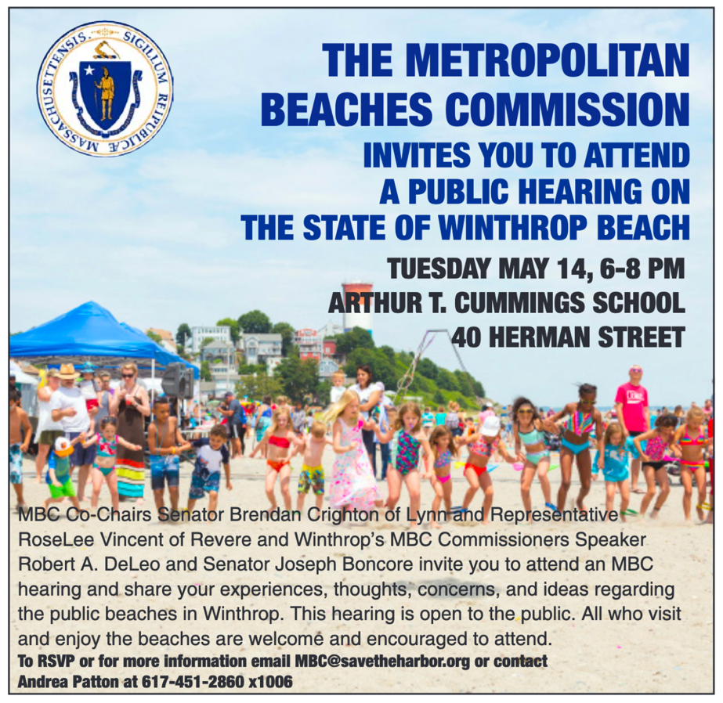

Winthrop Shore Drive
- Attendees were overwhelmingly complimentary of the recently completed Winthrop Shore Drive capital improvements.
  - Particular mention was made of the new, wider sidewalks, the berm and flood prevention, and the new park at Crest Ave.
- That said, there were some concerns that the new sidewalks were already experiencing damage, that the new lighting is too intense, that there are too many street signs along the road, more elevation for flood prevention is needed, and final touches such as removing the trailers and painting the wall remain to be completed.
- Some concerns about erosion do remain, and participants noted a need for planting native grasses and having a green space/grassy area.

Activities, Vendors, and Restaurants
- Participants appreciate the activities that take place at Winthrop Beach, especially those put on by the Friends of Winthrop Beach group.
- Folks would like to see more activities, more communication about them, and more utilization of the new park at Crest Ave.
- Participants had ideas for improvements that could bring in more activities including a pier, a kayak/boat launch, and a stage with electricity for bands.
- Several attendees also expressed a desire for more vendors with beach gear and kayak rentals, as well as more dining options more casual than the sit down restaurant Rossetti’s (although everyone praised Rossetti’s).

Amenities
- Participants love the benches, showers, and picnic area at Winthrop Beach.
- Beach goers would like to have more bathroom access in terms of hours and dates, and believe the bathrooms themselves could be improved.
- A few folks also would like more shaded areas.
- Three suggestions for improvements to the amenities include a designated smoking area, watering stations, and a common storage area for accessibility items like beach wheelchairs.

Daily Maintenance and Beach Management
- Several participants praised DCR’s efforts for trash pick up, plowing, and responding to heavy flooding.
- A few participants would like there to be more trash cans and to see more weeding.
- One group also discussed having a sifter or other mechanism for removing rocks from the sandy area.
- A few folks also requested more lifeguards, and better handicapped access to the beach such as mobility mats.
- Most groups also discussed ideas for changing the regulations around allowing dogs on the beach. Most participants would like increased access for dog owners including morning and/or evening hours during the entire year. One participant also expressed a desire for a designated off-leash dog area between April and September.
  - All participants recognized that dog owners who don’t pick up after their dogs are a large part of reason for regulations. They mentioned increased the dog bag dispensers and increasing enforcement of, or even fines related to, not picking up dog waste.
- A handful of comments regarding the piping plovers focused on frustration with having such a large space set aside for them.

